Exercise 2 (Day 3)
––Publish a .NET Project
Step 1: Right-click on the project name in the Solution Explorer and click on Publish.
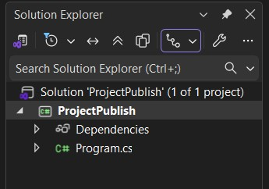

Step 2: Select publish target as Folder.
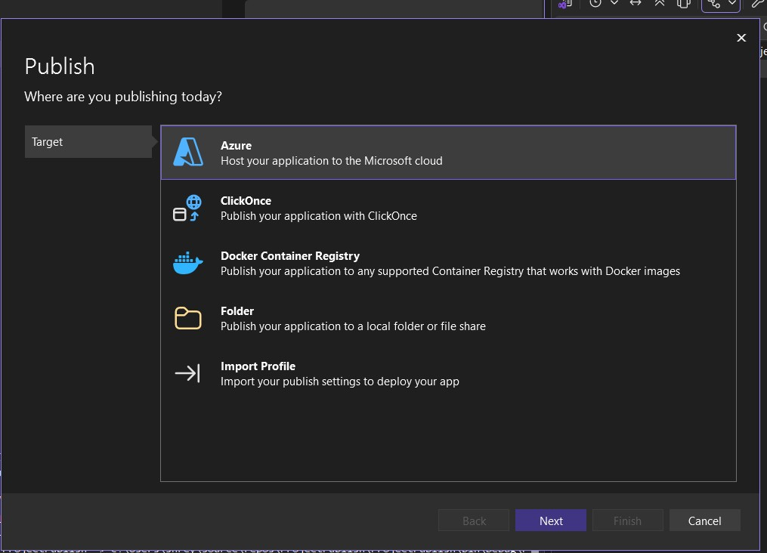
Step 3: Select specific target also as Folder.
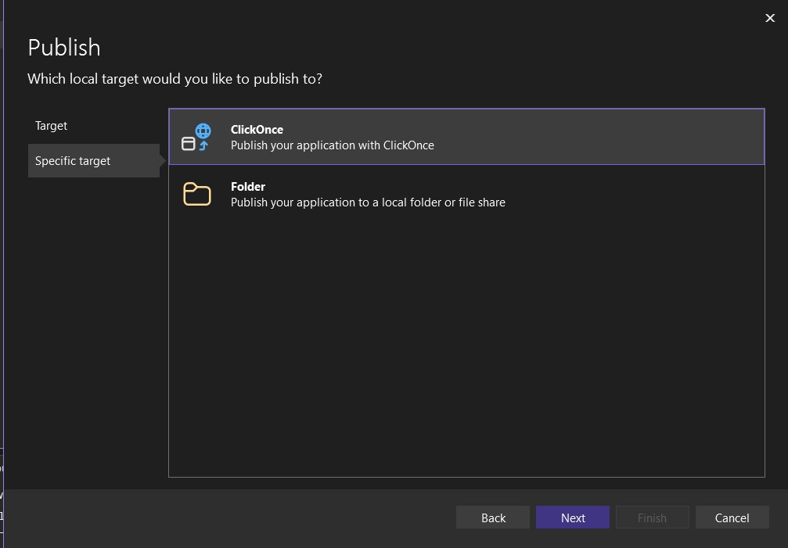

Step 4: Specify the location where you want to save the release.
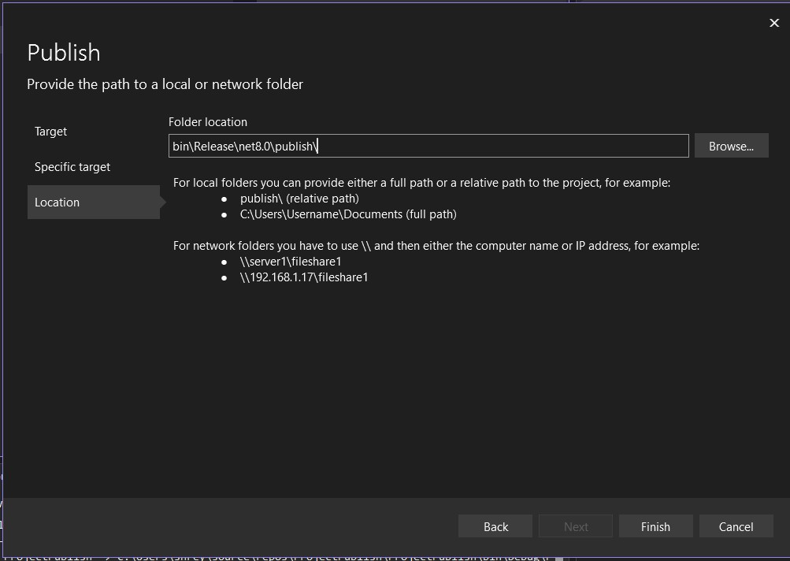

Step 5: After creating the Publish Profile, click on ‘Show all settings’, to choose Deployment mode, Target runtime.
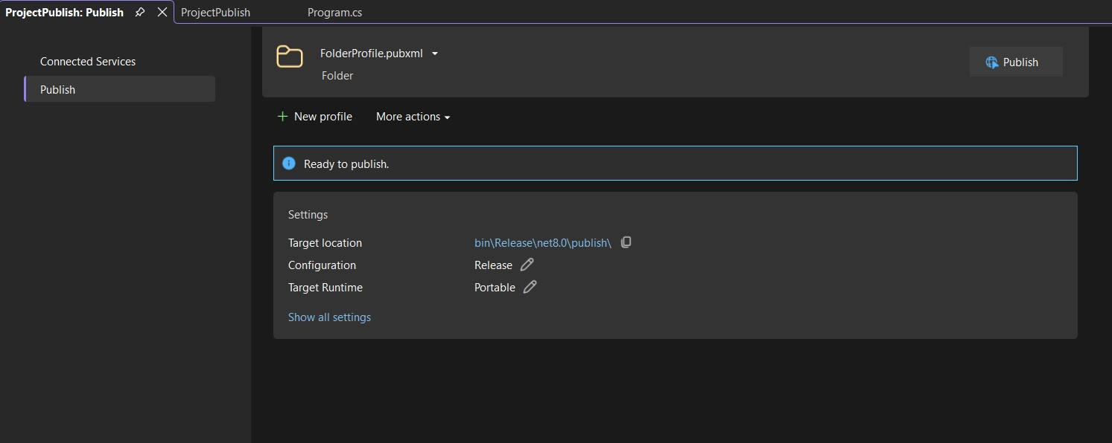
Portable Deployment (Framework – Dependent)
Portable Deployment produces a single build that runs on any OS where the matching .NET runtime is already installed.
- No OS specified
- No runtime bundled
- Smaller output
- Depends on installed .NET
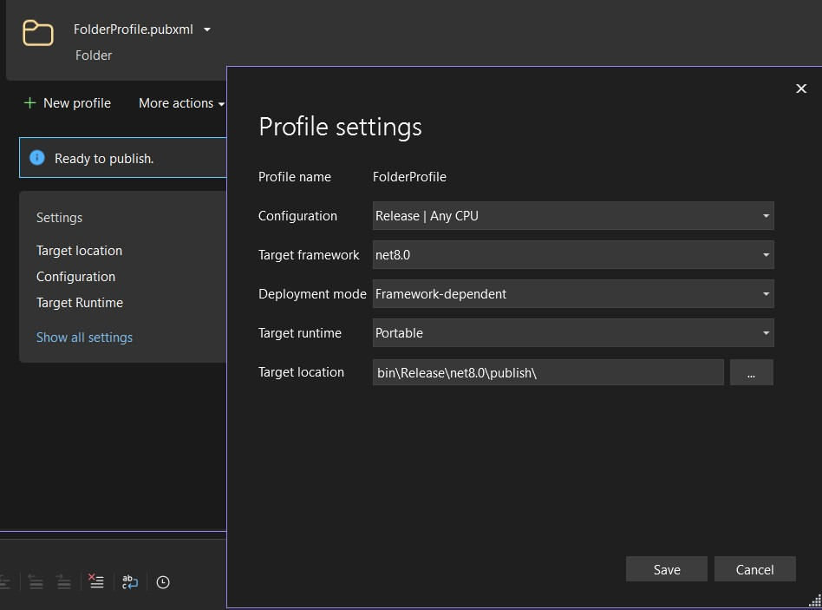
OS-Targeted Deployment (Self-Contained)
OS-Targeted deployment produces a build for a specific operating system and CPU architecture, bundling the .NET runtime with the app.
- OS explicitly specified
- Runtime included
- Larger output
- Runs without .NET preinstalled
